

**BLG 477E**

**MULTIMEDIA COMPUTING**

CRN: 22539

INSTRUCTOR: HAZIM KEMAL EKENEL

**ASSIGNMENT #2**

**Otsu’s Segmentation**

Submission Date: 15.04.2015

STUDENT NAME: TUĞRUL YATAĞAN

STUDENT NUMBER: 040100117

# Introduction

In this project Otsu’s binary segmentation algorithm is implemented with MATLAB. The main idea of Otsu’s algorithm is to find threshold that would maximize between-class variance and minimize within class variance. Then, all pixels are classified into two classes using that threshold.

# Development and Operating Environments

MATLAB R2012b has been used on Ubuntu 14.04 operation system.

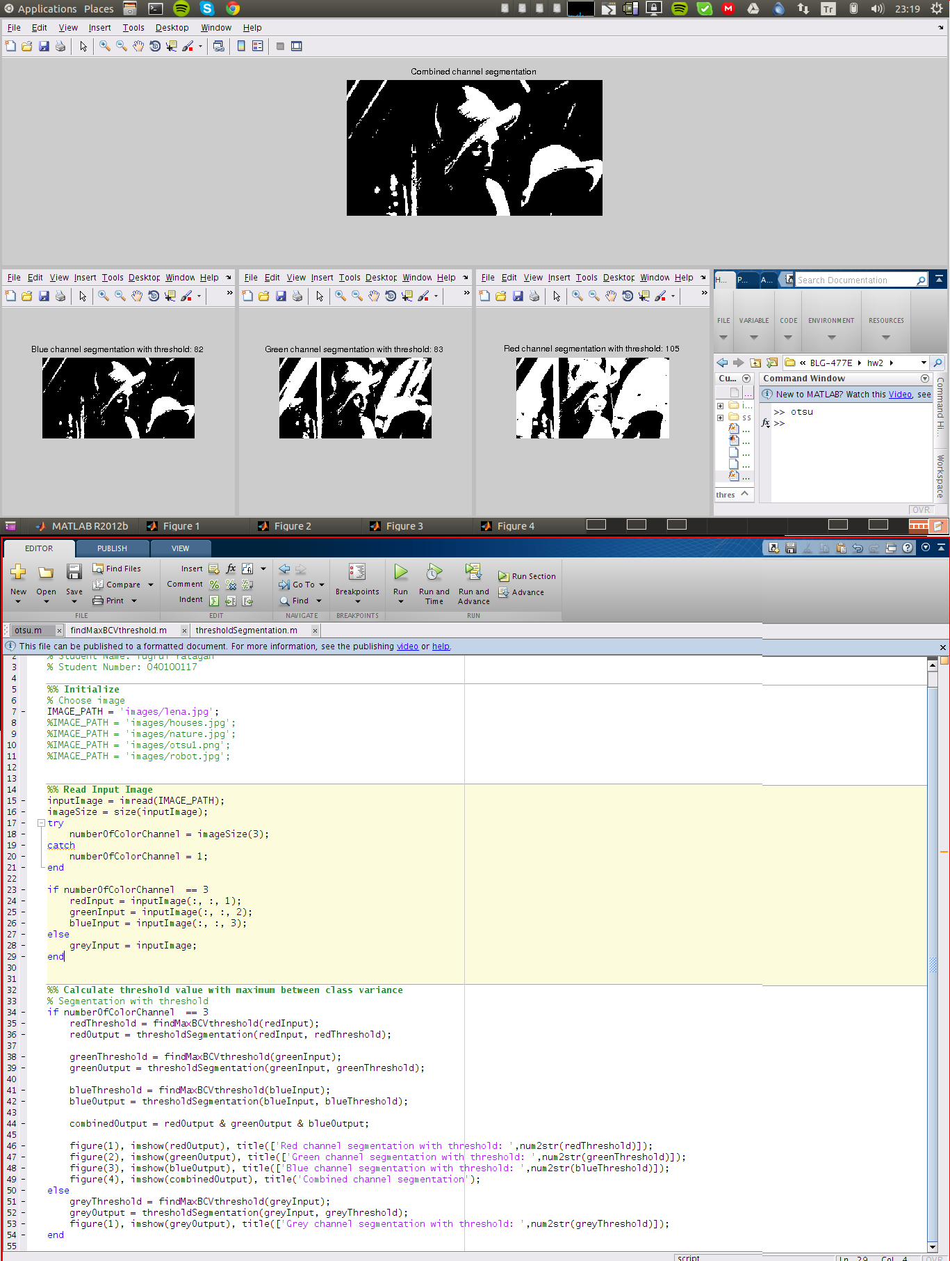

# Analysis of Otsu’s Algorithm Stages

Algorithm has several stages. These steps are done in otsu.m main source file consecutively with MATLAB.

* findMaxBCVthreshold.m function;

1. Calculates histogram values
2. Calculates probability distribution
3. Calculates sum of probability (ω) values
4. Calculates mean (μ) values
5. Calculates between class variance (σ2) values
6. Finds threshold value for maximum between class variance

* thresholdSegmentation.m function segments image with given threshold.

First step is to create a histogram of pixel values. We compute histogram h with 256 bins where the height of each bin corresponds to number of pixels that have that pixel value. Given an image, we can estimate probability of pixel value pi by simply dividing the height of hi in the histogram by the total number of pixels N. Given threshold k, probability of class 0 is sum of probabilities of pixel values smaller than k. Since the goal is to maximize between class variance, we need to calculate the means and the variances of both classes. It is sufficient to increase between class variance meanwhile within-class variance decreases. We calculate the between-class variance for each threshold k for 0 to 255 and picked the threshold that maximizes the between-class variance.

Maximum between class variance is calculated and optimal threshold value is calculated for every three channel for RGB images. After threshold segmentation these three channels are combined with and operation.

**Red channel segmentation with threshold value: 105**

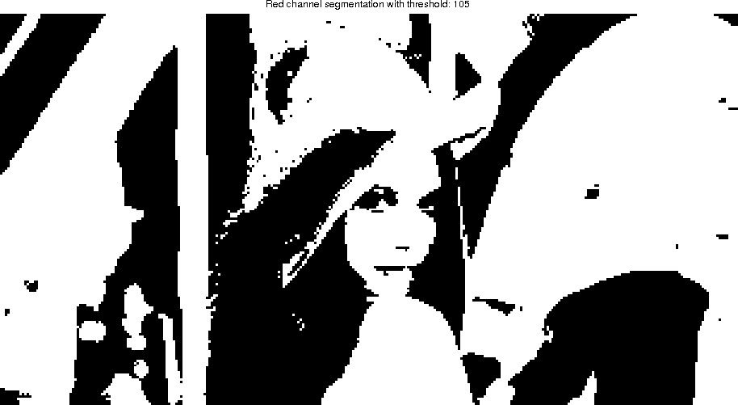

**Green channel segmentation with threshold value: 83**

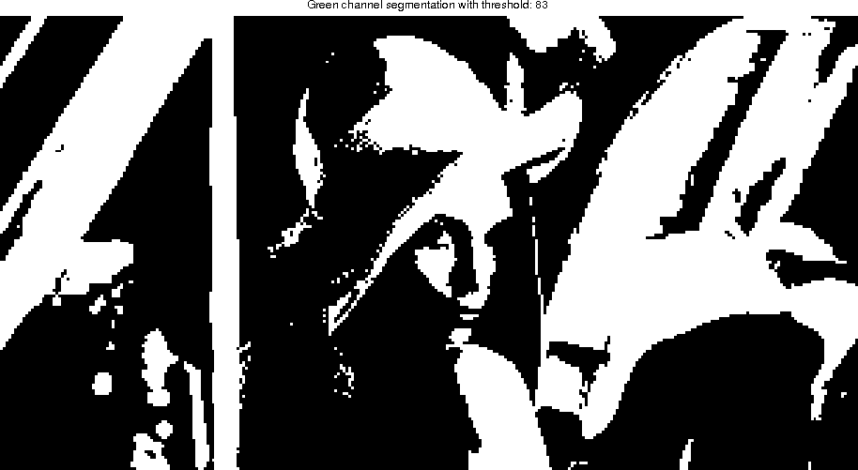

**Blue channel segmentation with threshold value: 82**

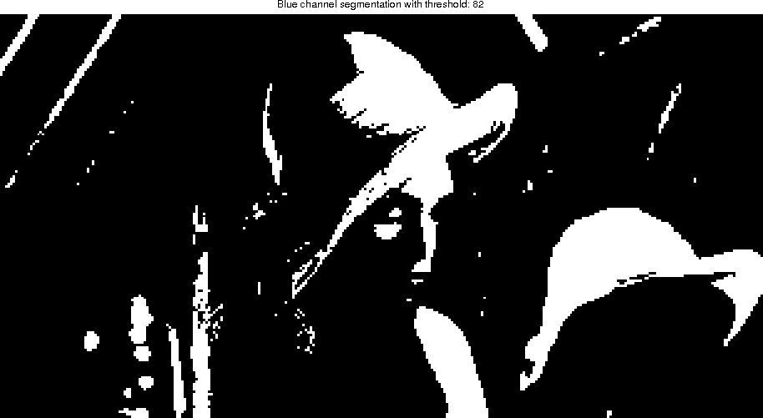

**All channels combined segmentation**

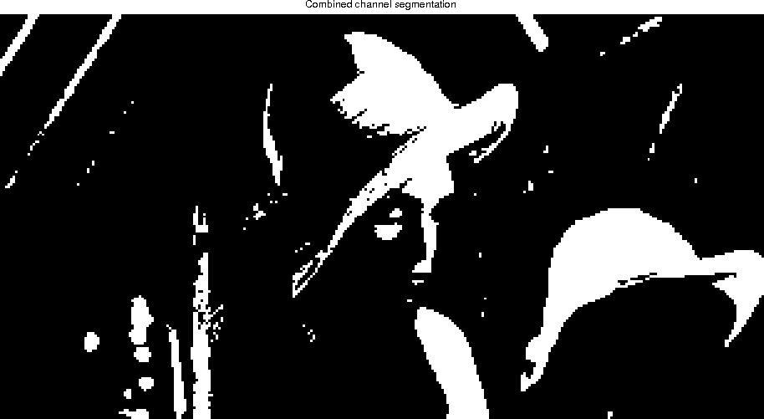

Grayscale images doesn’t need to channel combine operation.

**Houses grey channel segmentation with threshold value: 155**

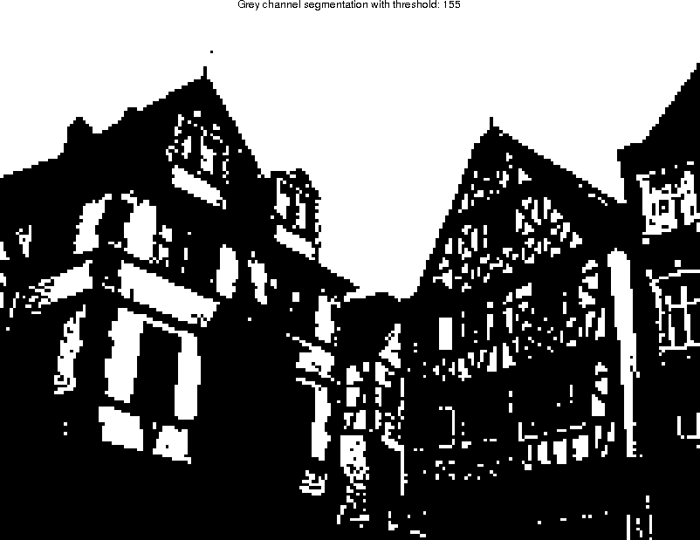

# Final Results of Other Images

**Nature all channel combined segmentation**

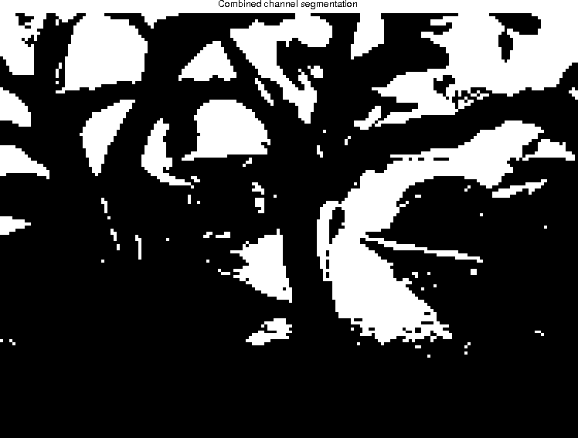

**Robot all channel combined segmentation**

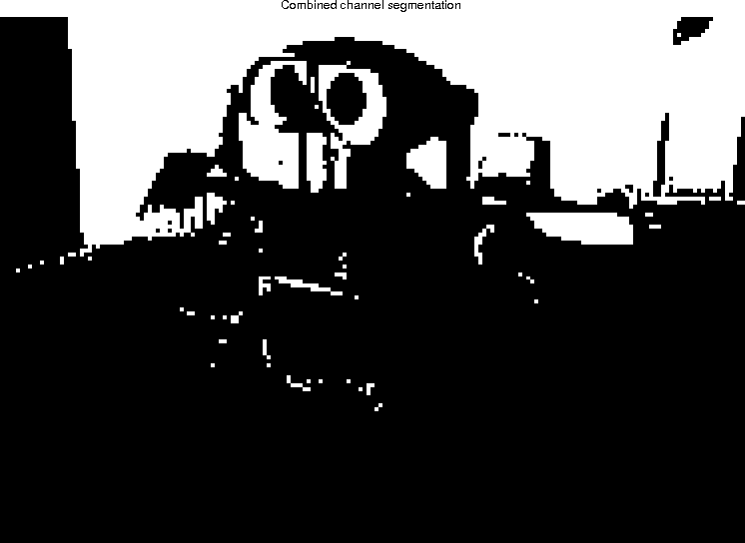

**Otsu grey channel segmentation with threshold value: 27**

